**Getting started with Postgres**

For Mac users, after that you have installed PostgreSQL, please follow the steps given below to get started:

1. Open the Terminal, at the shell prompt, type:

vim ~/.bashrc

1. The on-screen text editor (named VIM) will appear in the Terminal.   
   Copy the following lines (using Command + c) on your Mac’s keyboard:

export PSQL_DIR=/Applications/Postgres.app/Contents/Versions/11/bin

export PATH="$PSQL_DIR:$PATH"

1. Go back to the Terminal, while in VIM editor, press the i key on your keyboard. That will invoke the Insert mode.
2. Paste (using Command + v on your Mac’s keyboard) the 2 statements that you’ve copied from the previous step. I would suggest to paste them into the top of the bashrc file.
3. Press the esc button on your keyboard.
4. Press the colon (:) button on your keyboard.
5. Type: wq
6. Press Enter on your keyboard.
7. You should be returned to the shell prompt in the Terminal. At this point, type:  
   source ~/.bashrc
8. In your Mac, start the Postgres app by clicking on the icon.  
     
   
9. You should see this after starting the Postgres app.  
   Click the Start button.  
   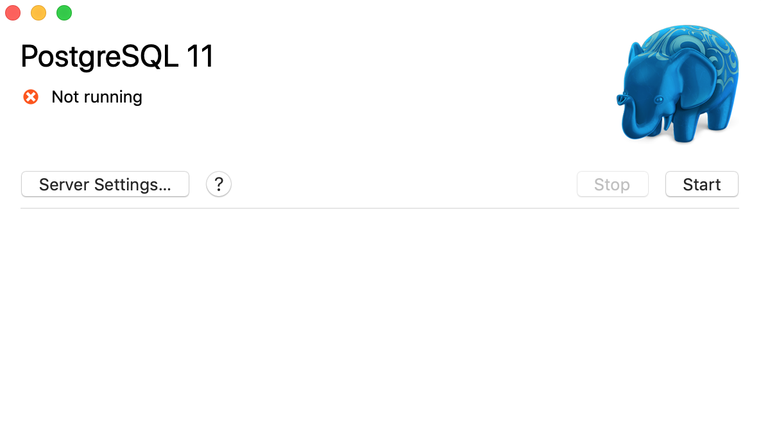
10. Next, go back to the Terminal, then type:  
    psql
11. You should see the following:  
    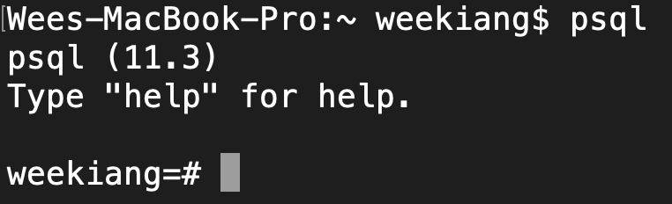
12. You are now inside the Postgres shell. Everything you type in the Postgres shell will be sending commands or instructions to Postgres directly.   
    Next, type:  
    \l  
    (backslash small L). You will see a list of all the current databases that you have in Postgres.
13. Type the following to create a new database:

CREATE DATABASE pony;

1. Next, type:  
   \l

You should see the pony database that you have created.

1. Next, type:  
   \c pony

You are now inside the pony database.

1. Next, type:

create table customers (

id BIGSERIAL NOT NULL PRIMARY KEY,

first_name VARCHAR(50) NOT NULL,

last_name VARCHAR(50) NOT NULL,

email VARCHAR(50),

gender VARCHAR(50) NOT NULL,

country VARCHAR(50) NOT NULL

);

1. Next, type:

insert into customers (first_name, last_name, email, gender, country) values ('Anne', 'Smith', 'anne@asmith.com', 'Female', 'Banana Republic');

insert into customers (first_name, last_name, email, gender, country) values ('Jake', 'Jones', 'jj001@live.com', 'Male', ' Slovenia');